- EULER’S METHOD
AIM: TO WRITE A PROGRAM IN PYTHON TO DEMONSTARTE EULER’S METHOD.
PROGRAM:
# Euler_method.py
# Solve dy/dx = -y with y(0)=1 using Euler's method

def f(x, y):
"""The ODE: dy/dx = -y"""
return -y

def euler(x0, y0, h, x_target):
"""Euler's method to approximate y(x_target)"""
steps = int((x_target - x0) / h)
x = x0
y = y0

print("Step | x | y ")
print("-----|--------|---------")
print(f" 0 | {x:.2f} | {y:.6f}")

for i in range(1, steps + 1):
# Euler formula: y(i+1) = y(i) + h * f(x(i), y(i))
y = y + h * f(x, y)
x = x + h

SIWS COLLEGE PRACTICAL NO 5
print(f"{i:3d} | {x:.2f} | {y:.6f}"
return y
if _name_ == "_main_":
# initial values
x0 = 0.0
y0 = 1.0
h = 0.01
x_target = 0.04

result = euler(x0, y0, h, x_target)

print(f"\nApproximate value at x={x_target:.2f}:", round(result, 6))

OUTPUT:
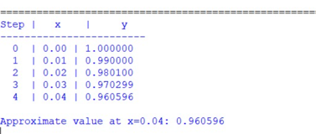
CONCLUSION: THE ABOVE PRAOGRAM HAS BEEN EXECUTED SIUCCESSFULLY.

SIWS COLLEGE PRACTICAL NO 5

